**NASA Proposes Spraying Stratospheric Aerosols Into Earth’s Atmosphere**

April 18, 2014 by [Arjun Walia](http://www.collective-evolution.com/author/arjun/). [228 Comments.](http://www.collective-evolution.com/2014/04/18/nasa-admits-to-chemtrails-as-they-propose-spraying-stratospheric-aerosols-into-earths-atmosphere/#comments)

|  |
| --- |
|  |
| SHARES |

115

115



It’s really amazing how many people are waking up to the fact that “chemtrails” are different from “con-trails.” What was once considered a conspiracy to many is now a fact, chemicals are constantly sprayed into our atmosphere and have been for quite some time now.

Not long ago, NASA personnel gave a lecture (that was also streamed live) at their Jet Propulsion Laboratory at the California Institute of Technology. It was a series of talks by scientists and engineers exploring the topic of Geoengineering and Climate Intervention. [(1)](http://www.ustream.tv/recorded/29293171)

Some of you might be thinking, “Geoengineering, what is that?” Geoengineering encompasses strategies to combat and reduce the effects of global warming and climate change. It’s the deliberate and large-scale intervention in the Earth’s climatic system, and one of these methods, as illustrated in the lecture, is called Solar Radiation Management (SRM) by spraying stratospheric aerosols into the atmosphere. [(1)](http://www.ustream.tv/recorded/29293171) The lecture outlines how SRM would require the equivalent of airplanes spraying aerosols into our atmosphere for decades. You can see this at approximately the 32 minute mark. It seems it’s already happening .

These programs are also considering spraying Aluminum into the atmosphere (if not already doing it).

**“There might be some good reasons to think about aluminum. Aluminum has four times the volumetric rate for small particles as does sulphur. That means you have roughly 16 times less the coagulation rate, and that’s the thing that really drives removal.”** – David Keith, Canadian Environmental Scientists, Professor of Applied Physics at Gordon McKay, Professor of Public policy, Harvard University, President of Carbon Engineering. [(2)](https://www.youtube.com/watch?v=jf0khstYDLA)

The idea of spraying aluminum into our atmosphere goes way back, patents exist that clearly demonstrate the consideration of such materials that include the oxides of metals which have high emissivity. These include harmful substances like aluminum oxide and thorium oxide. A great patent example is one from the Hughes Aircraft Company that dates all the way back to 1990, that’s over twenty years ago. You can take a look at it [here](http://www.google.com/patents/US5003186?dq=5003186).

*“We do stuff in the stratosphere all the time off-course, so it’s not as though the stratosphere is absolutely pristine. But you don’t want to have people going off and doing things that involve large radioactive forgings, or programs that go on for extended periods or for that matter provide lots of reactive surfaces that could result in significant ozone destruction.”*

M. Granger Morgan, Carnegie Mellon University, University and Lord Chair Professor of Engineering and Public Policy, National Academy of Sciences Member [(2)](https://www.youtube.com/watch?v=jf0khstYDLA)

Did you know that “they” do stuff in the atmosphere all the time? Is he referring to the Department of Defense? These programs are indeed backed by agencies like the CIA and NASA, they support the National Academy of Sciences with regards to geoengineering projects, and still do till this day. ([3](http://phys.org/news/2013-07-cia-co-sponsoring-geoengineering-reversing-global.html))([4](http://www.businessinsider.com/cia-weather-control-with-geoengineering-2013-7))Why are Defense Intelligence Agencies in control? Is this a national security issue? If so, that means happenings with regards to geoengineering might remain classified.

Below is a visual I used from a previous article to give you a good idea about SRM.

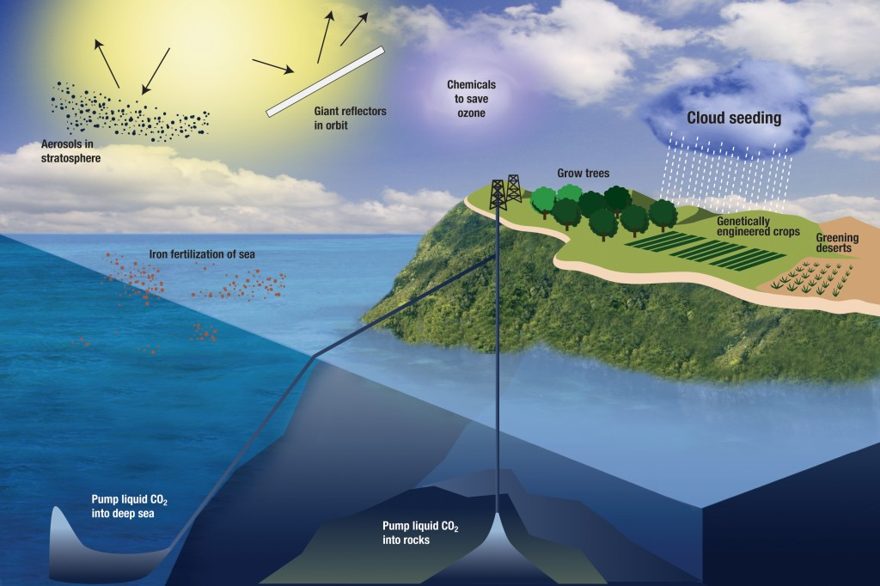

If you are a constant observer of the skies, as I am, it’s not hard to see that something is already going on. This has been voiced by various individuals from all over the world. For example, Rosalind Peterson, president and Co-Founder of the Agriculture Defense Coalition (ADC), and x United States Department of Agriculture (USDA) employee stated at a 2007 United Nations hearing on global warming that:

*“One of the things that’s affected by climate change is agriculture, but some of what we are seeing is man made, but man made in a different way than what you may guess. Weather modification programs, experimental ones done by private companies, the US government, are underway and there are more than 50 operations underway across the United States. All of these impact agriculture because they change the micro-climates needed for agriculture to survive. None of these programs are done with oversight. International corporations are modifying our weather all the time, and modifying it in ways that cover thousands and thousands of square miles. Most of it is chemically altered, so what happens is that we are putting ground based chemicals that are shot into the air that change and modify our weather.”*

You can read more, and view that full hearing [here](http://www.collective-evolution.com/2014/03/22/chemtrails-discussed-at-united-nations-hearing-on-global-warming-2/).

A former premier of British Columbia felt so strong about the issue that he sent out a letter across Canada to multiple politicians voicing his concern. You can read more about that [here](http://www.collective-evolution.com/2013/08/25/chemtrails-are-happening-all-over-the-world-according-to-former-british-columbia-premier/). Neurosurgeon Russel L. Blaylock made some noise about health concerns as a result of nanoaluminum spraying, you can read about that [here](http://www.collective-evolution.com/2013/11/01/neurosurgeon-voices-health-concerns-over-geoengineering-and-chemtrails/).

Anybody who looks out their window on a bright day and watches these trails will notice them spread out and expand until the sky is covered with them. Contrails don’t do that.

There is plenty of evidence to suggest that these geonengineering techniques have already begun, and were initiated a long time ago.

As far as global warming goes, that’s another controversial topic. There is no doubt climate change is occurring, but why and how is still not well understood. Is ‘global warming’ just a justification for geoengineering? Is geoengineering a cover for alternative agendas we don’t know about? These are important questions. No doubt that human activity has played a large role in the destruction of our environment.

There are better ways to operate here on planet Earth, ways that are more harmonious with the plant. One example is [Free Energy](http://www.collective-evolution.com/?s=free+energy), and another is [Solar](http://www.collective-evolution.com/?s=solar).

Below is a very informative video.

<http://www.collective-evolution.com/2014/04/18/nasa-admits-to-chemtrails-as-they-propose-spraying-stratospheric-aerosols-into-earths-atmosphere/>

**Related article:**

[Antarctic Sea Ice Extent Breaks All Time Record.](http://www.collective-evolution.com/2013/11/18/antarctic-sea-ice-extent-breaks-all-time-record/)

**Sources:**

[(1) http://www.ustream.tv/recorded/29293171](http://www.ustream.tv/recorded/29293171)

[(2) https://www.youtube.com/watch?v=jf0khstYDLA](https://www.youtube.com/watch?v=jf0khstYDLA)

[(3) http://phys.org/news/2013-07-cia-co-sponsoring-geoengineering-reversing-global.html](http://phys.org/news/2013-07-cia-co-sponsoring-geoengineering-reversing-global.html)

[(4) http://www.businessinsider.com/cia-weather-control-with-geoengineering-2013-7](http://www.businessinsider.com/cia-weather-control-with-geoengineering-2013-7)